Question # 2 (30.5 marks)
Complete the missing information (Rewrite in your answer notebook underlining the added required information)

- The functional component of biological membranes is ……………..….. and this component in plasmalemma fuctions mainly in ………….…………………………………. while in internal chloroplast membranes they function mainly in ……………………………………..

- Adjacent cells are connected through pores called ………………………

- Two of the functions of the plant cell vacuoles are:
- ………………………………………………………………………...
- …………………………………………………………………………

- The cellular organelles responsible for protein synthesis is called .………….. ……………… and there are two types of this organelle, the ……………… is responsible for synthesis of membrane proteins while …………………. is responsible for the free proteins.
- Microbodies in the plant cells are derived from ……………………………………… and ………………………………...

- ……………….. and …………………….. are partially self autonomous because each of them has ……………and …………………... and in this respect they are similar to …………………………

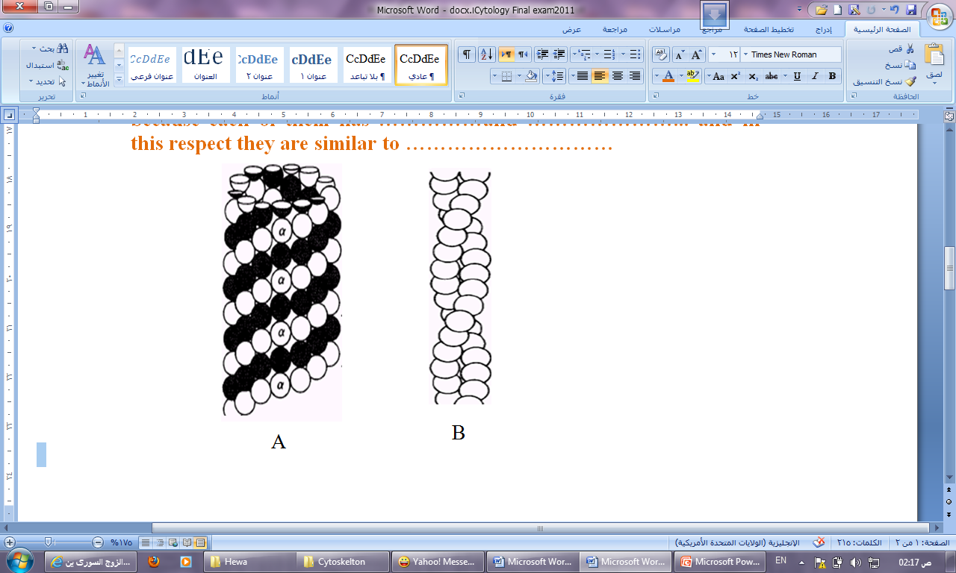

In this drawing:

- What does it show in A and B and what are the subunits of each
- The functions of each of them
- Where in the cell they can be found

Using sketch drawing, describe in short words how:
- The plant cell grows and determines its final shape
- Cytoplasmic streaming takes place
- ATP is synthesized in chloroplast
- The cell gets rid of H₂O₂

Question # 2
Check TRUE ( √ ) OR FALSE ( X ) and if False Rewrite the correct information:
- Preprophase ring determines where in the cell will be the cell division plane
- Plant cell exocytose only in the case of cell wall material excretion.
- Selective permeability is determined by phospholip component in the membrane.
- Chemosomosis is the process in which protoplast shrinks in middle of the cell away from the wall when cell is exposed to higher concentration solution.
- Ribosomes are synthesized in the endoplasmic reticulum.
- Signal reception is one of the functions of cell plasmalemma.
- Chloroplast and mitochondria in the plant cells can synthesize some of their proteins independent of nuclear DNA.
- Nuclear Sap containing RNA and DNA is enveloped by double membrane traversed by opened pores.
- Ribosomes in the cell wall is responsible for synthesis of elastin and other cell wall proteins.
- ATP synthase responsible for ATP synthesis is found the Nucleous , Chloroplast and Endoplasmic reticulum

